The Authority of the Channel Islands Racing & Hunt Club
(the “Authority”)
Registration of a Racing Club under the Rules of Racing

Section 1: Club Details

Club Name
The word “Club” will appear after the submitted name e.g. First Past the Post Club.

Section 2: Club Manager Details

The Club Manager(s) will be the point of contact in the Club and with the Authority and will be able to sign and act on behalf of the Club. By registering as a Club Manager, the Club Manager is a member of the Club and is a registered owner.

Club Manager 1
Mr/Mrs/Miss/Ms |  | Date of Birth
Forename(s) |  | E-mail address
Surname |  | Telephone number
Nationality |  | Mobile number
Home Address

Club Manager 2
Mr/Mrs/Miss/Ms |  | Date of Birth
Forename(s) |  | E-mail address
Surname |  | Telephone number
Nationality |  | Mobile number
Home Address

Section 2: Colours Registration
Colours

Beige | Emerald Green | Mauve | Royal Blue
Black | Grey | Orange | White
Brown | Light Blue | Pink | Yellow
Dark Blue | Light Green | Purple
Dark Green | Maroon | Red

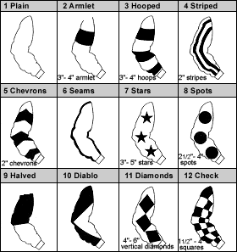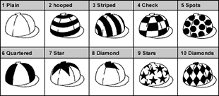

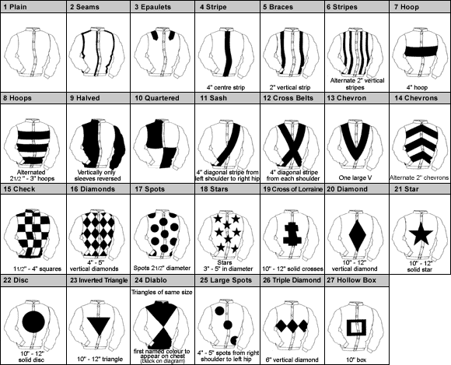

Racing colours are unique to each individual owner and consist of a combination of Jacket, Sleeves and Cap incorporating the specific designs, dimensions and colours on the previous page.

PLEASE ENTER THREE SELECTIONS IN ORDER OF PREFERENCE

First Choice
 | Design Number | Main Colour | Design Colour
Sleeves

Cap

Jacket

Second Choice
 | Design Number | Main Colour | Design Colour
Jacket

Sleeves

Cap

Section 3: Authority to Act – Nominate your Trainer

This section allows an owner to nominate their selected authorised trainer to carry out various administration procedures on their behalf including updating horse in training information as well as making entries & declarations.

First Trainer
Trainer name

Trainer Address
Second trainer (if applicable)
Trainer name
Trainer Address

I/We authorise the Authority to release my contact details to my trainer(s)

Section 4: Short Privacy Notice

We require your personal details (and all details of those involved in any ownership category) for client identity verification, subsequent client management and communications from the Authority. Your personal details are confidential and will only be shared with the Racecourse Managing Executives (which means the Jersey Race Club and the Guernsey Race Club) other foreign racing authorities or public judicial authorities for the specific purposes of racing administration and integrity purposes. We also share some elements of your personal details with our trusted data partners primarily in relation to data processing and race card information. Sharing of your data is strictly controlled and is carried out for specific purposes; your personal details will not be used by the Authority for marketing purposes. Aside from those parties referred to in this notice (which may change from time to time), your personal details will not be shared with any other third party.

This consent is required to facilitate your registration as an owner with the Authority.

Section 5: Declaration

I/We, the undersigned declare that all information provided is correct and true. We confirm that I/we are authorised to act on behalf of the members of the registered club and that all club members have been fully advised of the obligations and responsibilities of ownership. By completion of this form and registration as owners, we and the club members agree to be bound by the Rules of Racing (the “Rules”). We note that failure to comply with the Rules can result in sanction being imposed on any horse owned in share or full in accordance with the Rules. We also agree to issue each club member with a copy of the Club Rules, that will be signed and dated by the Club Manager/s. These Club Rules will be submitted to Authority with this Club Registration and will be resubmitted when updated.

Signature – Club Manager 1 |  | Date

Signature – Club Manager 2 |  | Date

PLEASE RETURN THIS FORM TO: Registry Office: Apartment 1, Sable Argente Apartments, La Route De St. Aubin, St. Helier, Jersey JE2 3SF OR EMAIL A SIGNED COPY TO STEWARDSSECRETARY@GMAIL.COM

CHEQUES SHOULD BE MADE PAYABLE TO: Channel Islands Racing & Hunt Club.

