The Authority of the Channel Islands Racing & Hunt Club
Registration of a Syndicate under the Rules of Racing

This form is necessary to register a syndicate in a horse to be raced on the track in the Channel Islands.  Each Syndicate must have at least one Syndicator. Each Syndicator is jointly and severally liable for any sums due from the Syndicate and is subject to all other liabilities, duties and privileges of ownership.  The Syndicator(s) is/are solely responsible for the management of the syndicate with the Authority.  The syndicate name will appear on the racecard.  Prior to completing this form we recommend that you refer to Schedule 5 (Syndicate Code of Conduct) of Manual (E) (Horse and Owner Manual) of the Rules of Racing. | It is compulsory that a separate written agreement is drawn up and signed by all syndicate members.  If you are registering your syndicate for the first time the Syndicator should have completed their own Owner Registration Form by this stage.  Current syndicates that are adding or replacing horses need to complete this form only. At this point may we remind you that the list of syndicate members must be identical in all horses owned by that syndicate. Any changes must be lodged in writing with the Authority.

Section 1: Horse Details

Name of horse 1 |  |  |  |  |  |  |  | Colour
Sire |  |  |  |  |  | Dam
Year of Foaling |  |  |  |  | Sex: Colt Mare Gelding (please tick where appropriate)
Trainer

Name of horse 1 |  |  |  |  |  |  |  | Colour
Sire |  |  |  |  |  | Dam
Year of Foaling |  |  |  |  | Sex: Colt Mare Gelding (please tick where appropriate)
Trainer

Name of horse 1 |  |  |  |  |  |  |  | Colour
Sire |  |  |  |  |  | Dam
Year of Foaling |  |  |  |  | Sex: Colt Mare Gelding (please tick where appropriate)
Trainer

Section 2: Syndicate Details

Syndicate Name

Name of Syndicator(s)

Syndicator(s) address

I consent to act as a Syndicator of the syndicate:

Syndicator’s Signature |  | Date
Section 3: Conditions of Syndicate Registration

We the undersigned agree to register the Syndicate in accordance with the Rule (E)48 of the Rules of Racing and agree to appoint the above named Syndicator(s) who shall be solely responsible for management of the syndicate with the Authority.  The Syndicate Registration shall terminate once the Authority is notified in writing by a Syndicator. The Syndicate Registration will incur an annual renewal charge on 1st January of every year it is registered. | The Authority shall not be under any liability whatsoever in respect of any payments by syndicate members to the Syndicator(s).  This form is prepared to meet the requirements of the Rules of Racing. It is not specially intended as a legal document and the interest of the parties concerned will therefore be best protected by the separate written agreement required by the Syndicate Code of Conduct.

Section 4: Membership Details of Syndicate Members

Mr/Mrs/Miss/Ms |  | Date of Birth
Forename(s) |  | E-mail address
Surname |  | Telephone number
Nationality |  | Mobile number
Home Address
Share |  | Signature

Mr/Mrs/Miss/Ms |  | Date of Birth
Forename(s) |  | E-mail address
Surname |  | Telephone number
Nationality |  | Mobile number
Home Address
Share |  | Signature

Mr/Mrs/Miss/Ms |  | Date of Birth
Forename(s) |  | E-mail address
Surname |  | Telephone number
Nationality |  | Mobile number
Home Address
Share |  | Signature
Mr/Mrs/Miss/Ms |  | Date of Birth
Forename(s) |  | E-mail address
Surname |  | Telephone number
Nationality |  | Mobile number
Home Address
Share |  | Signature

Mr/Mrs/Miss/Ms |  | Date of Birth
Forename(s) |  | E-mail address
Surname |  | Telephone number
Nationality |  | Mobile number
Home Address
Share |  | Signature

Mr/Mrs/Miss/Ms |  | Date of Birth
Forename(s) |  | E-mail address
Surname |  | Telephone number
Nationality |  | Mobile number
Home Address
Share |  | Signature

Mr/Mrs/Miss/Ms |  | Date of Birth
Forename(s) |  | E-mail address
Surname |  | Telephone number
Nationality |  | Mobile number
Home Address
Share |  | Signature

Mr/Mrs/Miss/Ms |  | Date of Birth
Forename(s) |  | E-mail address
Surname |  | Telephone number
Nationality |  | Mobile number
Home Address
Share |  | Signature

Section 5: Colours Registration
Colours

Beige | Emerald Green | Mauve | Royal Blue
Black | Grey | Orange | White
Brown | Light Blue | Pink | Yellow
Dark Blue | Light Green | Purple
Dark Green | Maroon | Red

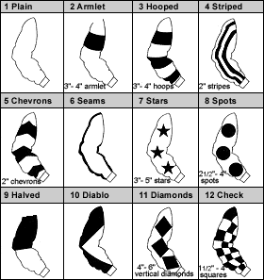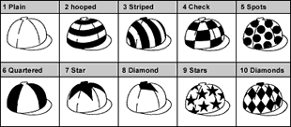

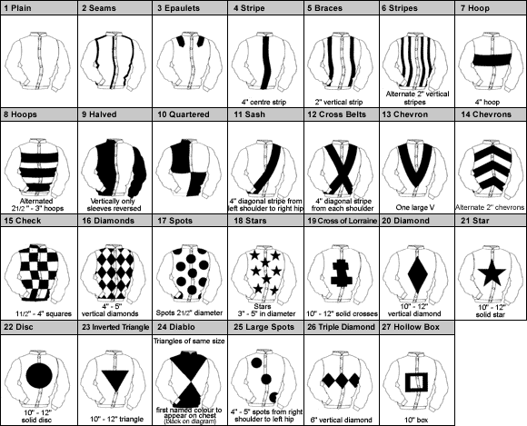

Racing colours are unique to each individual owner and consist of a combination of Jacket, Sleeves and Cap incorporating the specific designs, dimensions and colours on the previous page.

PLEASE ENTER THREE SELECTIONS IN ORDER OF PREFERENCE

First Choice
 | Design Number | Main Colour | Design Colour
Sleeves

Cap

Jacket

Second Choice
 | Design Number | Main Colour | Design Colour
Jacket

Sleeves

Cap

Section 6: Authority to Act – Nominate your Trainer

This section allows a Syndicator to nominate their selected authorised trainer to carry out various administration procedures on their behalf including updating horse in training information as well as making entries & declarations.

First Trainer
Trainer name

Trainer Address
Second trainer (if applicable)
Trainer name
Trainer Address

I authorise the Authority to release my contact details to my trainer(s)

Section 7: Short Privacy Notice

We require your personal details (and all details of those involved in any ownership category) for client identity verification, subsequent client management and communications from the Authority. Your personal details are confidential and will only be shared with the Racecourse Managing Executives (which means the Jersey Race Club and the Guernsey Race Club) other foreign racing authorities or public judicial authorities for the specific purposes of racing administration and integrity purposes. We also share some elements of your personal details with our trusted data partners primarily in relation to data processing and race card information. Sharing of your data is strictly controlled and is carried out for specific purposes; your personal details will not be used by the Authority for marketing purposes. Aside from those parties referred to in this notice (which may change from time to time), your personal details will not be shared with any other third party.

This consent is required to facilitate your registration of the Syndicate with the Authority.

PLEASE RETURN THIS FORM TO: Registry Office: Apartment 1, Sable Argente Apartments, La Route De St. Aubin, St. Helier, Jersey JE2 3SF OR EMAIL A SIGNED COPY TO STEWARDSSECRETARY@GMAIL.COM

CHEQUES SHOULD BE MADE PAYABLE TO: Channel Islands Racing & Hunt Club.

Manual (E) Schedule 5 - Syndicate Code of Conduct

- Code of Conduct

  - In accordance with Rule 52, this Code of Conduct applies to all ownership arrangements registered as a Syndicate where

    - the arrangement is managed, administered or promoted by a Syndicator who receives payment, in relation to their role, and/or
    - the method(s) of attracting participation in the arrangement include invitations to the public, whether by way of advertisement or otherwise.

  - The Syndicator must ensure that at the time of commencement of the Syndicate and throughout its duration, there is a written contract between the Syndicator and the participants which addresses and identifies, but may not be limited to, the following matters:

    - the express acknowledgement from the participant/s that membership of the Syndicate may not necessarily provide a financial return;
    - the intended duration of the Syndicate, the mechanism for its termination and the methods and conditions (if any) by which participants may leave the Syndicate other than on final termination;
    - whether the horse(s) is wholly owned by the participants or whether the horse is subject to a lease or other arrangement;
    - the number of horses involved in the Syndicate, the proportionate interest in the Syndicate of each participant and their rights of (or lack of) to sell, lease, transfer or assign their share/s;
    - the cost of participation for each participant and whether such cost is fixed or susceptible to alteration;
    - the details and/or means of calculating and paying any remuneration to be received by the Syndicator and any third parties;
    - a full financial statement for the Syndicate and the process by which any financial surplus or deficit will be credited or charged to the participants in the Syndicate;
    - the time at which and procedure by which the statement(s) of the Syndicate's costs recovered and expenditure will be presented to the participants. Such statement(s) shall be exclusive or inclusive of GST as appropriate depending upon the GST status of the Syndicate;
    - whether and in respect of which risks the horse(s) will be insured and whether the participants of the Syndicate are the beneficiaries;
    - whether the horse(s) will be initially trained by a named trainer; and
    - the process by which the Syndicate makes any decisions relating to the management, training, and time and method of sale of the horse(s).

  - This Code of Conduct does not purport to dictate the terms of the matters set out at Paragraph 1.2, only that they are matters that are to be agreed at the outset of a Syndicate. Each contract between the Syndicator and the participants in that Syndicate must contain materially identical terms on the matters set out in Paragraph 1.2.

  - Each participant in the Syndicate should be aware that they are bound by the Rules of Racing. Particular attention should be drawn to those Rules prohibiting the sharing of Inside Information (Rule (A)29).

Note:
In all cases it is the responsibility of the participant in the Syndicate on complaint of a failure to comply with this Code of Conduct to provide to the Authority the evidence which the Authority considers necessary to support that allegation.

