The Channel Islands Horseracing Authority
Company Registration under the Rules of Racing

Section 1: Company Details

Name of Company
Place of incorporation |  | Registered number
Registered Office Address |  | Correspondence Address (if different to registered office)

Section 2: Shareholder and Director Details

Please provide the names and addresses of all shareholders with a shareholding of 25% of greater, the names and addresses of all directors and the company secretary

Name of shareholder and % owned |  | Address
Name of shareholder and % owned |  | Address
Name of shareholder and % owned |  | Address
Name of Director |  | Address
Name of Director |  | Address
Name of Director |  | Address
Name of Company Secretary |  | Address

Is the Company or has the Company previously been a registered owner in the Channel Islands or abroad? |  |  | Yes No
If the answer to this question is Yes, please state what country:
Have the Company ever appeared on a Forfeit List in any country? |  | Yes No
If Yes, please state what country:
Section 3: Colours Registration
Colours

Beige | Emerald Green | Mauve | Royal Blue
Black | Grey | Orange | White
Brown | Light Blue | Pink | Yellow
Dark Blue | Light Green | Purple
Dark Green | Maroon | Red

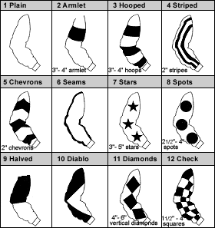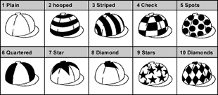

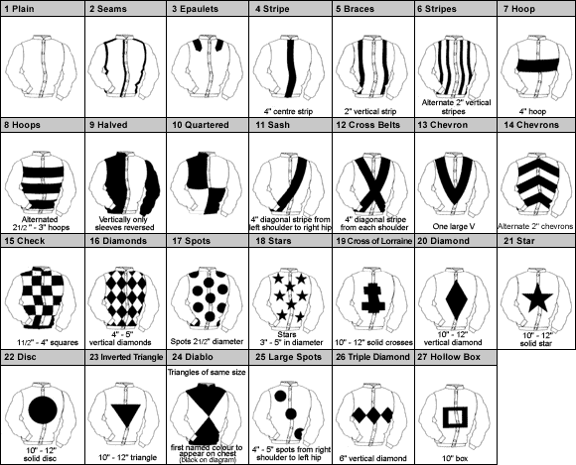

Racing colours are unique to each individual owner and consist of a combination of Jacket, Sleeves and Cap incorporating the specific designs, dimensions and colours on the previous page.

PLEASE ENTER THREE SELECTIONS IN ORDER OF PREFERENCE

First Choice
 | Design Number | Main Colour | Design Colour
Sleeves

Cap

Jacket

Second Choice
 | Design Number | Main Colour | Design Colour
Jacket

Sleeves

Cap

Section 4: Registered Agent

The Registered Agent(s) will be the point of contact for the Company with the Authority and will be able to sign and act on behalf of the Company.

Registered Agent 1
Mr/Mrs/Miss/Ms |  | Date of Birth
Forename(s) |  | E-mail address
Surname |  | Telephone number
Nationality |  | Mobile number
Home Address

Registered Agent 2
Mr/Mrs/Miss/Ms |  | Date of Birth
Forename(s) |  | E-mail address
Surname |  | Telephone number
Nationality |  | Mobile number
Home Address

Section 5: Authority to Act – Nominate your Trainer

This section allows an owner to nominate their selected authorised trainer to carry out various administration procedures on their behalf including updating horse in training information as well as making entries & declarations.

First Trainer
Trainer name

Trainer Address
Second trainer (if applicable)
Trainer name
Trainer Address

We authorise the Authority to release my contact details to my trainer(s)

Section 4: Short Privacy Notice

We require the personal details of persons connected with the Company (and all details of those involved in any ownership category) for client identity verification, subsequent client management and communications from the Authority. Your personal details are confidential and will only be shared with the Racecourse Managing Executives (which means the Jersey Race Club and the Guernsey Race Club) other foreign racing authorities or public judicial authorities for the specific purposes of racing administration and integrity purposes. We also share some elements of your personal details with our trusted data partners primarily in relation to data processing and race card information. Sharing of your data is strictly controlled and is carried out for specific purposes; your personal details will not be used by the Authority for marketing purposes. Aside from those parties referred to in this notice (which may change from time to time), your personal details will not be shared with any other third party.

This consent is required to facilitate the Company’s registration as an owner with the Authority.

Section 5: Declaration

We, the undersigned declare that all information provided is correct and true. By completion of this form and registration as owners we agree to be bound by the Rules of Racing (the “Rules”) and acknowledge that breach of same may result in disciplinary action. We note that failure to comply with the rules by individuals can result in sanction being imposed on any horse owned by them in share or full in accordance with the Rules.

Signature |  | Date
Print Name |  | For and on behalf of the Company

Signature |  | Date
Print Name |  | For and on behalf of the Company

PLEASE RETURN THIS FORM TO: Registry Office: Apartment 1, Sable Argente Apartments, La Route De St. Aubin, St. Helier, Jersey JE2 3SF OR EMAIL A SIGNED COPY TO STEWARDSSECRETARY@GMAIL.COM

CHEQUES SHOULD BE MADE PAYABLE TO: Channel Islands Racing & Hunt Club.

