The Authority of the Channel Islands Racing & Hunt Club
Registration of Colours under the Rules of Racing

Section 1: Owner Details

Owner/Syndicate/Company/Club Name
Address
Signature |  |  |  | Date

Section 2: Colours Registration
Colours

Beige | Emerald Green | Mauve | Royal Blue
Black | Grey | Orange | White
Brown | Light Blue | Pink | Yellow
Dark Blue | Light Green | Purple
Dark Green | Maroon | Red

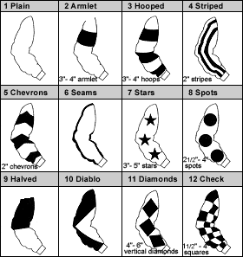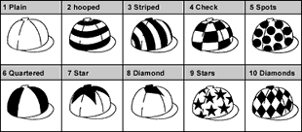

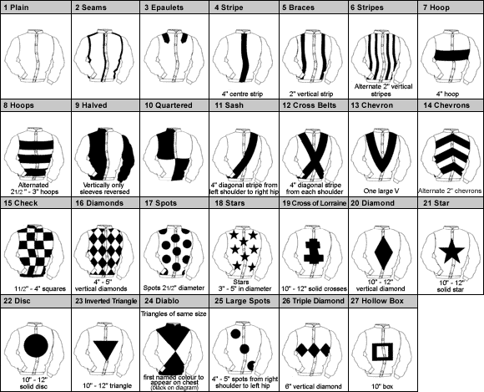

Racing colours are unique to each individual owner and consist of a combination of Jacket, Sleeves and Cap incorporating the specific designs, dimensions and colours on the previous page.

PLEASE ENTER THREE SELECTIONS IN ORDER OF PREFERENCE

First Choice
 | Design Number | Main Colour | Design Colour
Sleeves

Cap

Jacket

Second Choice
 | Design Number | Main Colour | Design Colour
Jacket

Sleeves

Cap

PLEASE RETURN THIS FORM TO: Registry Office: Apartment 1, Sable Argente Apartments, La Route De St. Aubin, St. Helier, Jersey JE2 3SF OR EMAIL A SIGNED COPY TO STEWARDSSECRETARY@GMAIL.COM

CHEQUES SHOULD BE MADE PAYABLE TO: Channel Islands Racing & Hunt Club.

