The Jersey Race Club
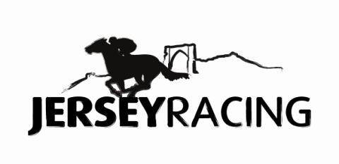

Sponsorship Packages

There is a number of sponsorship options available at Les Landes, and we would be delighted to build a package to suit your individual requirements and budget.

Sponsorship of a race is awarded to the winning owners of your chosen race in prize money and a trophy. As the race sponsor you will be invited to the parade ring before your race to enjoy the atmosphere, before returning to the winners enclosure where you will be asked to present prizes to the winning owners.

We realise that a big part of race sponsorship is the opportunity to promote your brand and raise the profile of your business to a wide audience. We are committed to developing sponsorship and entertainment packages to achieve this whilst maximising your enjoyment of the event.

The sponsored race will carry your chosen name, whether the name of your business or short advertising slogan (increasingly popular), which will be used in all media coverage including television and radio, broadcasts. Radio advertising can be organised if required.

The name will feature prominently in the race-card and space will also be provided for an advertisement or your business’ logo.

We will reserve a space on the rails where your banner can be positioned or perhaps have your logo printed on a blanket for the winning horse in your sponsored race!

We offer exclusive locations for private marquees with excellent views of the racetrack either on the rails or alongside the parade ring where you can view all the race day action. Your private area may be branded as you require.

A Tote betting point can be positioned in your marquee exclusively for your guests’ use, with a screen televising each race to ensure they miss none of the action.

As an alternative to a private marquee, take advantage of our member’s facilities to entertain your guests, with a food and beverage package, tailored by our on site caterers, to suit your requirements.

You will be supplied with complimentary “day members” badges giving your guests access to all areas of the racecourse. Each guest will also receive a full colour race-card including tips and “how to’s” for the novice racegoer it contains all the information your guests will need to make the most of their day.

Following your event, you will receive a photograph of your prize giving and an invitation to return as our guest at any of the meetings throughout the season.

Basic cost of sponsoring a race: £2,500 per race or £3,500 for one of nine feature races.

Sponsorship of the ‘Best Turned Out’ is also available for each of the nine race meetings across the season. Give your guests the chance to play an active role in the day’s racing by judging the Best Turned Out horse in each race.

Your hospitality requirements can be catered for as detailed above, your business name will be featured in the race card whilst additional advertising can be arranged to meet your requirements.

Basic cost of sponsoring ‘Best Turned Out’: £500 per meeting

Race Commentator Sponsorship. For each of the season’s nine meetings, we’re privileged to have secured the services of UK commentators who are at the very top of their profession. Leading names in racing are booked for a small fee plus expenses.

Ideal for a smaller organisation, your business name will be featured in the race card whilst additional advertising can be arranged to meet your requirements.

Basic cost of sponsoring Race Commentator: £350 per meeting

